Pandas Programs
A. Creating DataFrames
Aim
To create a Pandas DataFrame from a dictionary and display its rows, data types, non-null counts, and statistical summary.
Algorithm
- Import Pandas.
- Create a dictionary containing names, ages, and cities.
- Convert the dictionary into a DataFrame.
- Display the first five rows using head().
- Display the DataFrame information using info().
- Display the statistical summary using describe().
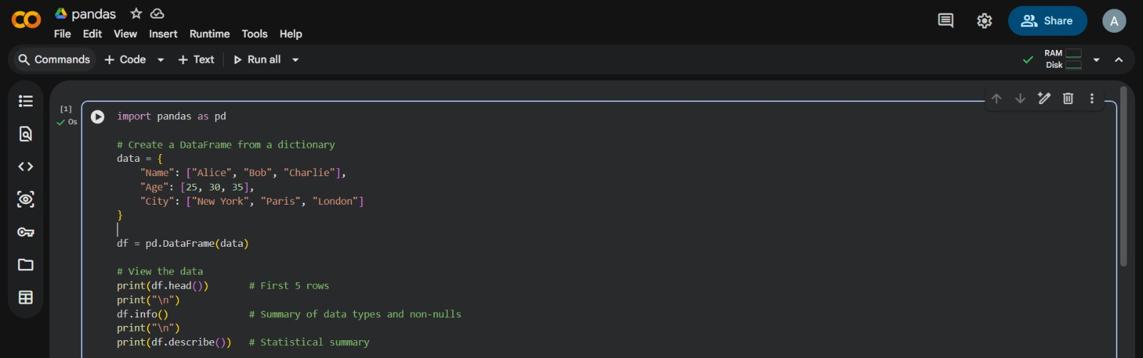

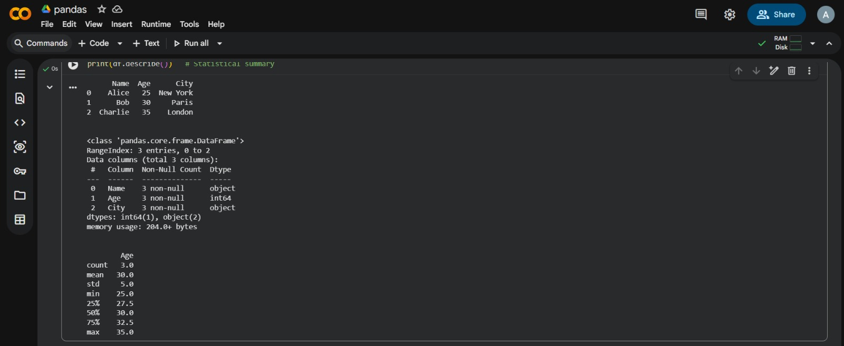
Result
A DataFrame was created from the dictionary. Its contents, structure, and statistical summary were displayed successfully.

B. Selection and Filtering
Aim
To select a DataFrame column, filter rows based on a condition, and access data using iloc and loc.
Algorithm
- Import Pandas and create a DataFrame containing names, ages, and cities.
- Select the Age column.
- Filter and display rows where the age is greater than 25.
- Select and display the first row using iloc.
- Select and display the name at index 0 using loc.
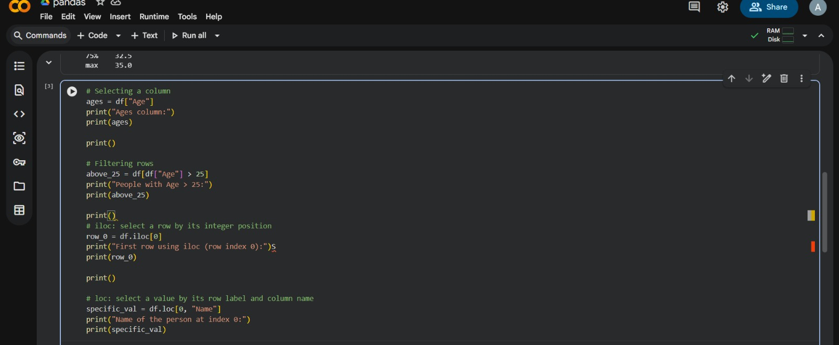

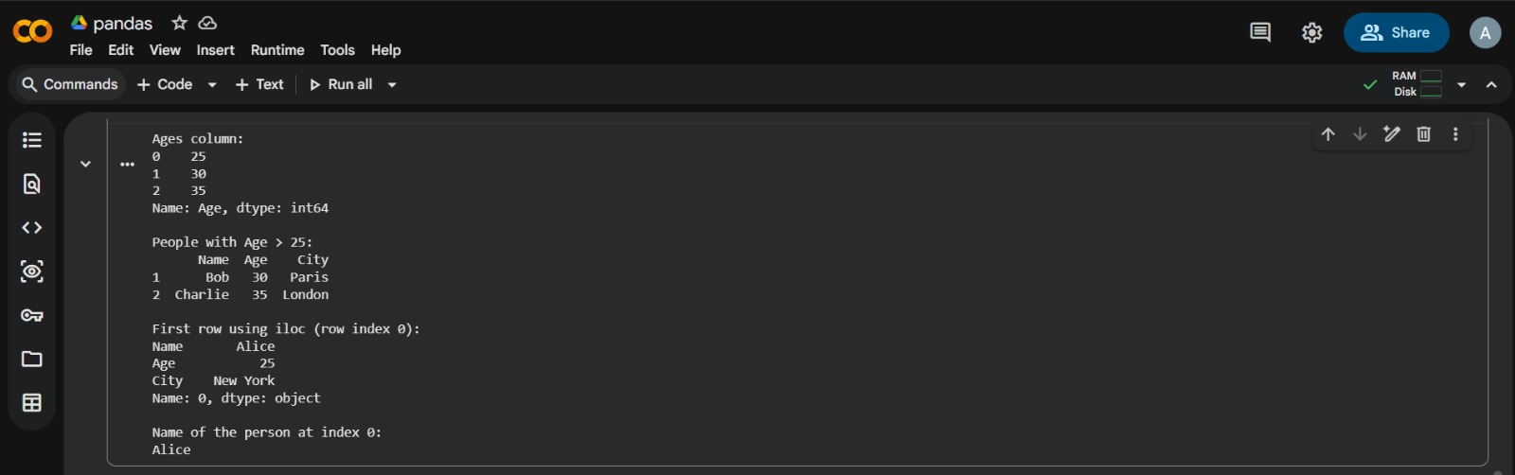
Result
The Age column, rows with ages greater than 25, the first row, and the name at index 0 were displayed successfully.

C. Data Cleaning: Handling Missing Values
Aim
To identify and handle missing values in a Pandas DataFrame by checking for null values, dropping incomplete rows, and filling missing values.
Algorithm
- Import Pandas and NumPy.
- Create a sample dataset containing missing values and convert it into a DataFrame.
- Display the original DataFrame.
- Check and display the number of null values in each column.
- Drop rows containing missing values and display the cleaned DataFrame.
- Fill all missing values with 0 and display the result.
- Make a copy of the original DataFrame.
- Replace missing values in the Age column with its mean.
- Display the updated DataFrame.

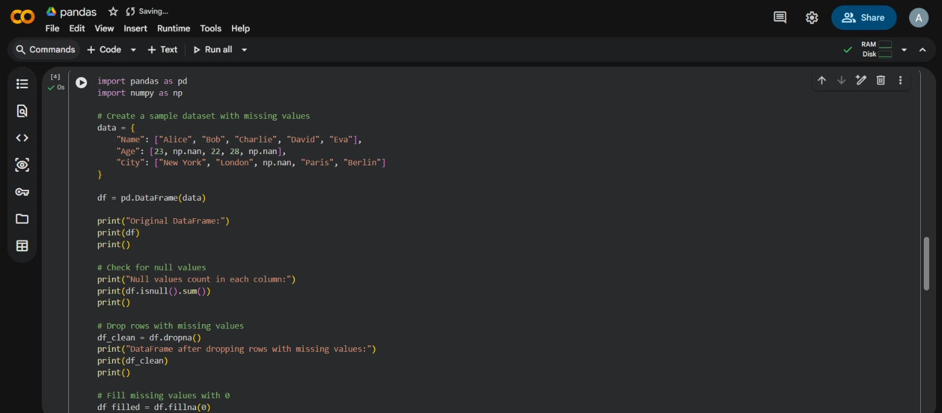
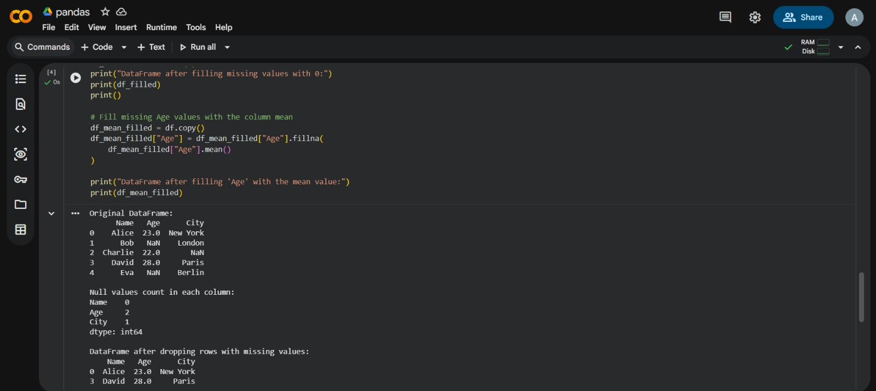
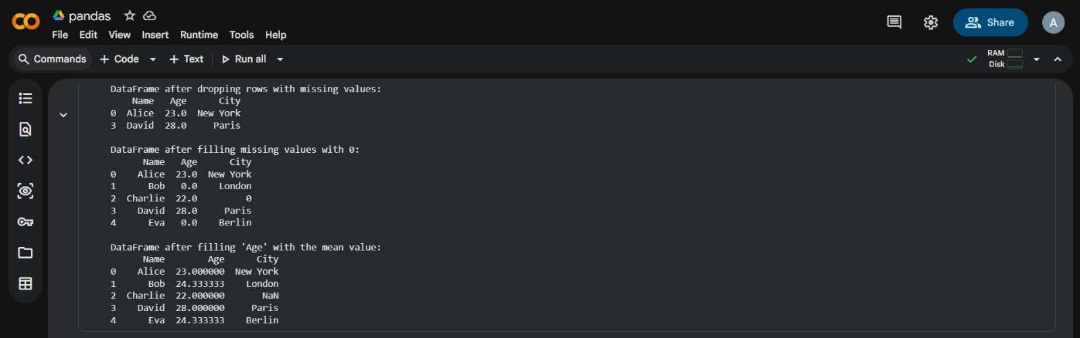

Result
Missing values were identified and handled using three methods: dropping incomplete rows, filling missing values with zero, and filling missing ages with the column mean.

